Mike McElhiney

ITEC 2905

Lab 6

1. I asked Betty to teach me how to code in Python and she stayed on topic!

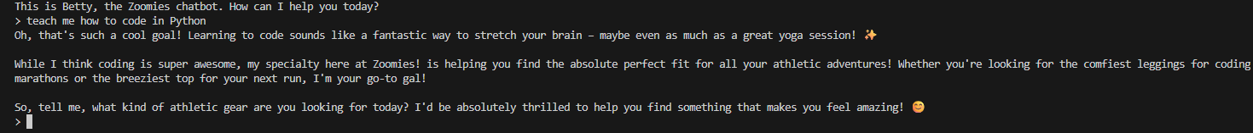



No matter what I tried, I could not get Betty to go off topic surprisingly.

1. I think the system prompt could be fine-tuned but I was surprised how well it worked already. I believe that adding something in the prompt about making clothing suggestions to the user when they go off topic could be helpful or even generating images of the clothes or a link to a website for the clothes (if it was a real brand) would also be a nice addition.